Link U

Zihao Wang 110794512

Haofeng Liang 111405314

Yingnan Li 111149515

ER diagram

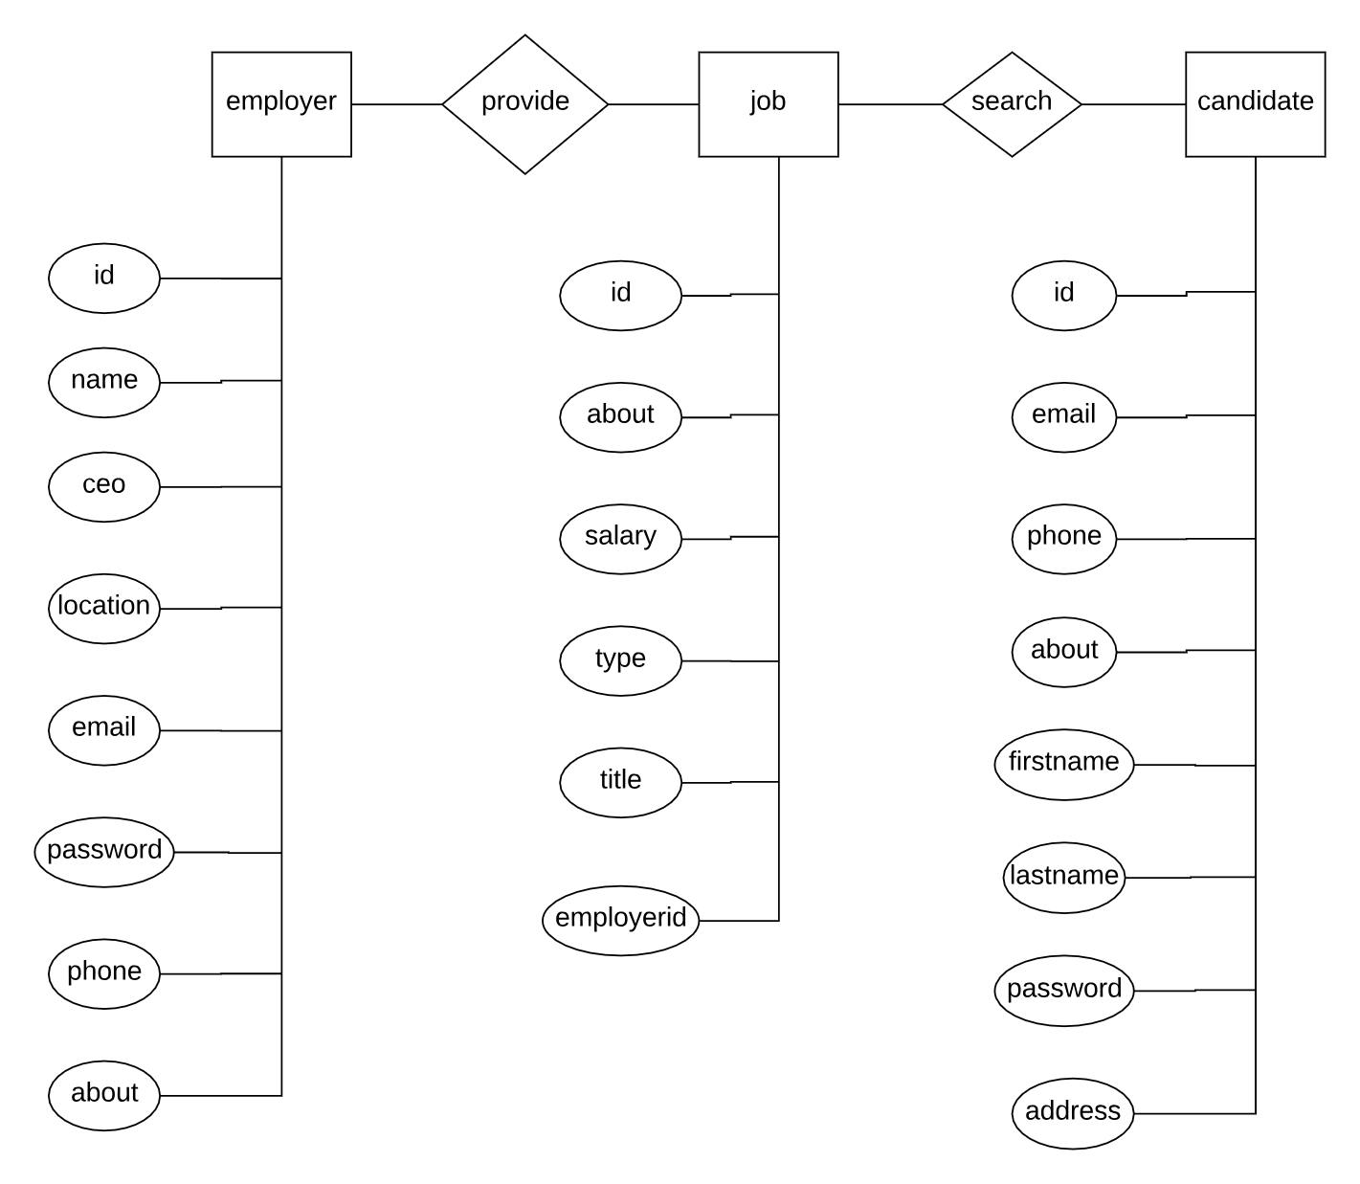

Employer Table SQL:

CREATE TABLE `employer` (

`id` int(9) NOT NULL AUTO_INCREMENT,

`name` char(255) CHARACTER SET utf8mb4 COLLATE utf8mb4_0900_ai_ci NOT NULL,

`ceo` char(255) CHARACTER SET utf8mb4 COLLATE utf8mb4_0900_ai_ci NOT NULL,

`location` char(255) CHARACTER SET utf8mb4 COLLATE utf8mb4_0900_ai_ci NOT NULL,

`email` char(255) CHARACTER SET utf8mb4 COLLATE utf8mb4_0900_ai_ci NOT NULL,

`password` char(255) CHARACTER SET utf8mb4 COLLATE utf8mb4_0900_ai_ci NOT NULL,

`phone` char(255) CHARACTER SET utf8mb4 COLLATE utf8mb4_0900_ai_ci DEFAULT NULL,

`about` char(255) CHARACTER SET utf8mb4 COLLATE utf8mb4_0900_ai_ci DEFAULT NULL,

PRIMARY KEY (`id`),

KEY `ID` (`id`),

KEY `ID_2` (`id`)

)

Job Table SQL:

CREATE TABLE `job` (

`id` int(9) NOT NULL AUTO_INCREMENT,

`about` char(255) CHARACTER SET utf8mb4 COLLATE utf8mb4_0900_ai_ci DEFAULT NULL,

`salary` double(10,0) DEFAULT NULL,

`type` char(255) CHARACTER SET utf8mb4 COLLATE utf8mb4_0900_ai_ci DEFAULT NULL,

`title` char(255) CHARACTER SET utf8mb4 COLLATE utf8mb4_0900_ai_ci DEFAULT NULL,

`employerid` int(9) DEFAULT NULL,

PRIMARY KEY (`id`),

KEY `employerid` (`employerid`),

CONSTRAINT `job_ibfk_1` FOREIGN KEY (`employerid`) REFERENCES `employer` (`id`) ON DELETE SET NULL

)

Candidate table SQL:

CREATE TABLE `candidate` (

`id` int(9) NOT NULL AUTO_INCREMENT,

`email` char(255) CHARACTER SET utf8mb4 COLLATE utf8mb4_0900_ai_ci DEFAULT NULL,

`phone` char(255) CHARACTER SET utf8mb4 COLLATE utf8mb4_0900_ai_ci DEFAULT NULL,

`about` char(255) CHARACTER SET utf8mb4 COLLATE utf8mb4_0900_ai_ci DEFAULT NULL,

`firstname` char(255) CHARACTER SET utf8mb4 COLLATE utf8mb4_0900_ai_ci DEFAULT NULL,

`lastname` char(255) CHARACTER SET utf8mb4 COLLATE utf8mb4_0900_ai_ci DEFAULT NULL,

`password` char(255) DEFAULT NULL,

`address` char(255) CHARACTER SET utf8mb4 COLLATE utf8mb4_0900_ai_ci DEFAULT NULL,

PRIMARY KEY (`id`)

)

Contribution

Haofeng Liang: most front end

Yingnan Li: frontend and backend

Zihao Wang: backend and database design